**Name**: _______________________________________

**Date**: ________________________________________

**Year 3 Criterion A: Knowing and Understanding**

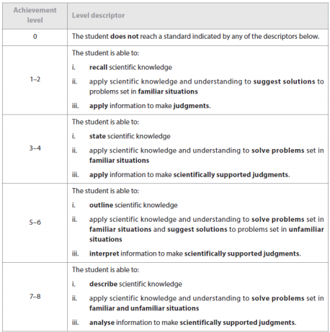

**Commentary: __________________________________________________**

**____________________________________________________________________________________________________________________________________________________________________________________________________________________________________________________________________________________________________________________________________________________________________________________________________________**

**IB Grade: _______ Conversion: __________**

**Name**: _______________________________________

**Date**: ________________________________________

**Year 3 Criterion A: Knowing and Understanding**

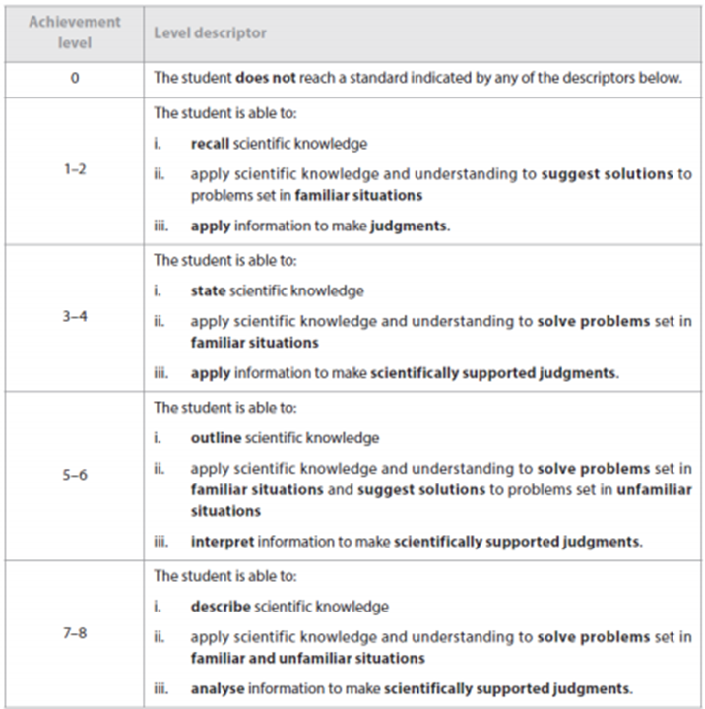

**Commentary: __________________________________**

**____________________________________________________________________________________________________________________________________________________________________________________________________________________________________________________________________________________________________________________________________________________________________________________________________________**

**IB Grade: _______ Conversion: __________**

**Name**: _______________________________________

**Date**: ________________________________________

**Year 3 Criterion B: Inquiring and Designing**

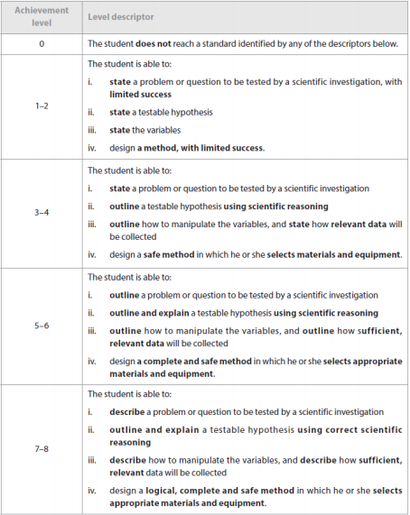

**Commentary: __________________________________________________**

**__________________________________________________________________________________________________________________________________________________________________________________________________________________________________________________________________________________________________________________________________________________________________________________________**

**IB Grade: _______ Conversion: __________**

**Name**: _______________________________________

**Date**: ________________________________________

**Year 3 Criterion B: Inquiring and Designing**

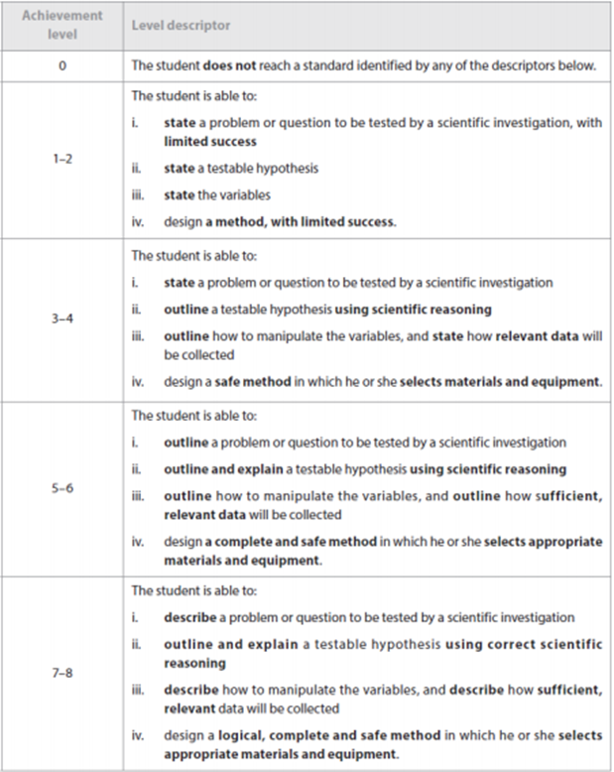

**Commentary: __________________________________________________**

**__________________________________________________________________________________________________________________________________________________________________________________________________________________________________________________________________________________________________________________________________________________________________________________________**

**IB Grade: _______ Conversion: __________**

**Name**: _______________________________________

**Date**: ________________________________________

**Year 3 Criterion C: Processing and Evaluating**

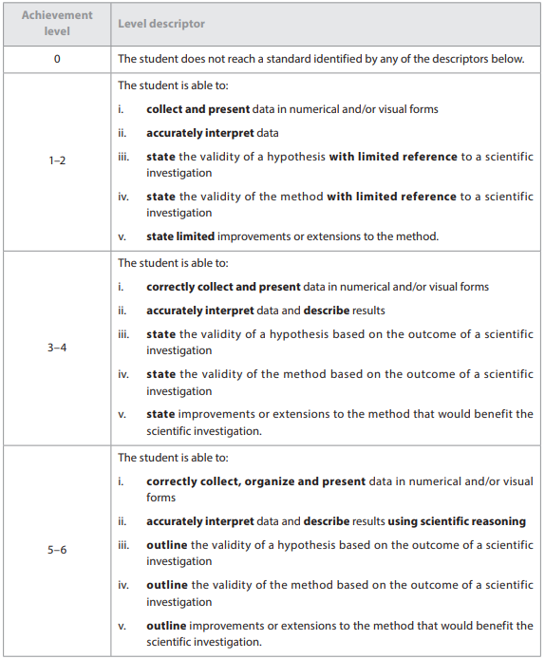

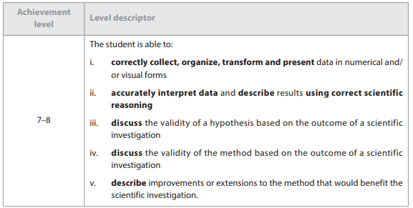

**Commentary: __________________________________________________**

**____________________________________________________________________________________________________________________________________________________________________________________________________________________________________________________________**

**IB Grade: _______ Conversion: __________**

**Name**: _______________________________________

**Date**: ________________________________________

**Year 3 Criterion C: Processing and Evaluating**





**Commentary: __________________________________________________**

**____________________________________________________________________________________________________________________________________________________________________________________________________________________________________________________________**

**IB Grade: _______ Conversion: __________**

**Name**: _______________________________________

**Date**: ________________________________________

**Year 3 Criterion D: Reflecting on the Impacts of Science**

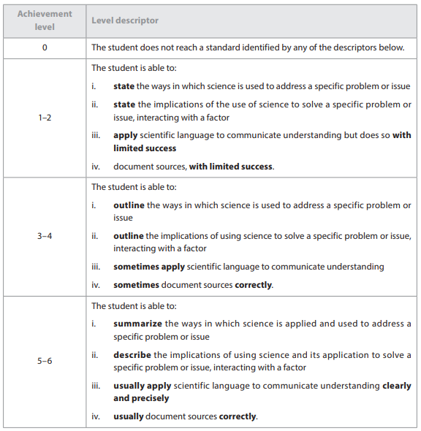

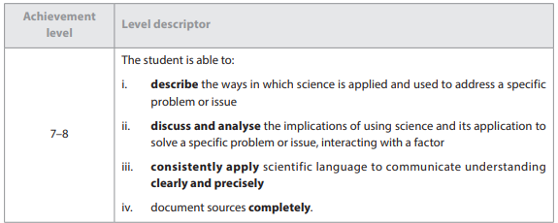

**Commentary: __________________________________________________**

**__________________________________________________________________________________________________________________________________________________________________________________________________________________________________________________________________________________________________________________________________________________________________________________________**

**IB Grade: _______ Conversion: __________**

**Name**: _______________________________________

**Date**: ________________________________________

**Year 3 Criterion D: Reflecting on the Impacts of Science**





**Commentary: __________________________________________________**

**__________________________________________________________________________________________________________________________________________________________________________________________________________________________________________________________________________________________________________________________________________________________________________________________**

**IB Grade: _______ Conversion: __________**